What is software engineering?

Software engineering is an engineering discipline that is concerned with all aspects of software production from the early stages of system specification through to maintaining the system after it has gone into use.

* Software specification,
* software development,
* software validation, and
* software evolution.

What is a Software Development process?

It is also known as a software development life cycle (SDLC).

It’s an abstraction that represents a software life cycle for the purpose of understanding, monitoring, or controlling the development of a software system.

What are the fundamental software engineering activities/phases?

* **Software specification** – the functionality of the software and constraints on its operation must be defined.
* **Software design and implementation** – the software to meet the specification must be produced.
* **Software validation** – the software must be validated to ensure that it does what the customer wants.
* **Software evolution** – the software must evolve to meet changing customer needs.

Waterfall process is:

1. Linear
2. Iterative
3. Interactive
4. Rapid

Spiral process begins with:

1. Design
2. Risk analysis
3. Programming
4. Communication with the client

What is the meaning or RUP?

1. Real-time unified process
2. Rational unified process
3. Rapid unified process

What is the meaning of XP?

1. Excellent programming
2. Extreme programming
3. Extreme programming
4. Excellent programming

When waterfall process should be used?

Waterfall process should only be used when the requirements are well understood and unlikely to change during system development.

How can prototyping be used in the following software development phases: requirement engineering AND implementation

In requirements engineering it can be used to validate the requirements and in implementation it can be used to test the earliest version of the software.

What things does an analyst need to consider in order to apply the Agile process to software development?

in custom system development within an organization, where there is a clear commitment from the customer to become involved in the development process and where there are not a lot of external rules and regulations that affect the software.

What are the differences between Agile and plan-driven development?

* Plan driven approaches involve a significant overhead in planning, designing, and documenting the system
* It is justified when:
  + The work of multiple development teams has to be coordinated
  + When the system is a critical system
  + When many different people will be involved in maintaining the software over its lifetime.
* Agile methods allow the development team to focus on the software itself rather than on its design and documentation.
* They are best suited to application development where the system requirements usually change rapidly during the development process.

Give examples of advantages and disadvantages with XP

**Advantages:**

* Collective Ownership for the code created and the results of the project.
* Continuous informal Review process because each code line is looked at by at least 2 people
* It supports Refactoring, which is a continuous process of software improvement
* Less time is spent on repairing bugs.
* Improved Code Quality
* It reduces the overall risk

**Disadvantages:**

* Some specialists say that Extreme Programming is focused on the code rather than on design. That may be a problem because good design is extremely important for software applications. It helps sell them in the software market. Additionally, in XP projects the defect documentation is not always good. Lack of defect documentation may lead to the occurrence of similar bugs in the future.
* One more disadvantage of XP is that this methodology does not measure code quality assurance. It may cause defects in the initial code.
* XP is not the best option if programmers are separated geographically.

Suggest of software project where it may be beneficial to use Scrum

When a client doesn't have a clear expectations of what kind features does the software project needs

Give examples of advantages and disadvantages with Scrum

**Advantages:**

* Scrum can help teams complete project deliverables quickly and efficiently
* Scrum ensures effective use of time and money
* Large projects are divided into easily manageable sprints
* Developments are coded and tested during the sprint review
* Works well for fast-moving development projects
* The team gets clear visibility through scrum meetings
* Scrum, being agile, adopts feedback from customers and stakeholders
* Short sprints enable changes based on feedback a lot more easily
* The individual effort of each team member is visible during daily scrum meetings

**Disadvantages:**

* Scrum often leads to scope creep, due to the lack of a definite end-date
* The chances of project failure are high if individuals aren’t very committed or cooperative.
* Adopting the Scrum framework in large teams is challenging
* The framework can be successful only with experienced team members
* Daily meetings sometimes frustrate team members
* If any team member leaves in the middle of a project, it can have a huge negative impact on the project
* Quality is hard to implement until the team goes through an aggressive testing process

What features are used in XP?

* Small, frequent releases of the system – requirements are based on simple customer stories.
* Continuous engagement of the customer in the development team – is responsible for defining acceptance tests for the system
* Pair programming, collective ownership of the system code, and a sustainable development process, Code Reviews, Standup Meetings

What is RUP?

* **RUP - Rational Unified Process**
* RUP is so-called hybrid process model.
* It takes elements from many of the traditional plan driven methods as well iterative / incremental delivery, which is an important part of Agile methods.
* The RUP has been designed to work together with UML (Unified Modelling Language)

What is the importance of project management?

Project management helps define a time for the tasks required in the project and also there is risk management. (vague answer)

Project management is the discipline of planning, organizing, motivating, and controlling resources to achieve specific goals.

Software project management comprises of activities, which contains planning of project, deciding scope of software product, estimation of cost in various terms, scheduling of tasks and events, and resource management.

Main Project management activities:

* Project Planning
* Scope Management
* Project Estimation

What project scheduling tools you know?

The **Gantt chart** gives an overview of tasks, subtasks, milestones, resources, etc. in a project.

**PERT (Program Evaluation & Review Technique) chart** is a tool that depicts project as network diagram.

It is capable of graphically representing main events of project in both parallel and consecutive way.

* Events, which occur one after another, show dependency of the later event over the previous one.
* Events are shown as numbered nodes. They are connected by labeled arrows depicting sequence of tasks in the project.

What is requirement engineering?

The process of finding out, analyzing, documenting and checking the services and constraints of a software is called **requirements engineering (RE)**.

What is user requirements?

User requirements are **high-level abstract requirements.**

User requirements are statements, in a natural language plus diagrams, of what services the system is expected to provide to system users and the constraints under which it must operate.

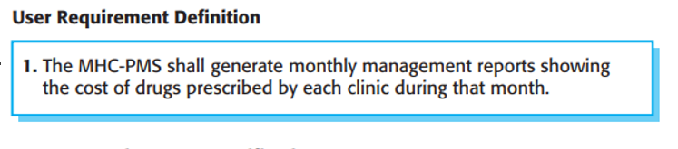

What is system requirements?

System requirements **detailed description of what the system should do**.

System requirements are more detailed descriptions of the software system’s functions, services, and operational constraints.

The system requirements document (sometimes called a functional specification) should define exactly what is to be implemented.

* It may be part of the contract between the system buyer and the software developers.

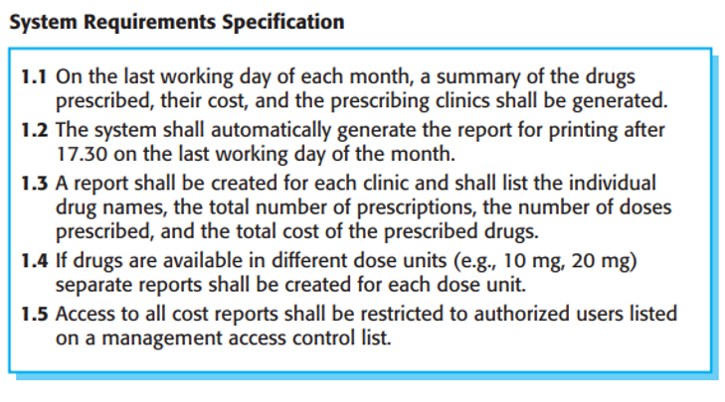

What are the properties of a good requirement?

The properties of a good requirements are the requirements that aren't conflicting, aren’t ambiguous and they are clear.

The functional requirements specification of a system should **complete and consistent**.

* Completeness means that all services required by the user should be defined.
* Consistency means that requirements should not have contradictory definitions.

**(idk, not sure about this, pls help)**

What is requirement validation?

**Requirements validation** is the process of checking that requirements actually define the system that the customer really wants.

It overlaps with analysis as it is concerned with finding problems with the requirements.

**Good validation => less rework because of errors**

**Requirement validation checks:**

1. **Validity checks -** Systems have diverse stakeholders with different needs and any set of requirements is inevitably a compromise across the stakeholder community.
2. **Consistency checks -** Requirements in the document should not conflict (should not be contradictory constraints or different descriptions of the same system function)
3. **Completeness checks -** The requirements document should include requirements that define all functions and the constraints intended by the system user.
4. **Realism checks -** the requirements should be checked to ensure that they can actually be implemented (+ budget and schedule for the system development).
5. **Verifiability -** requirements should always be written so that they are verifiable => you should be able to write a set of tests that can demonstrate that the delivered system meets each specified requirement.

What methods of requirements discovery(elicitation) do you know?

By having interview with the client